Catering

B/Ella Chow-Food and Catering Services

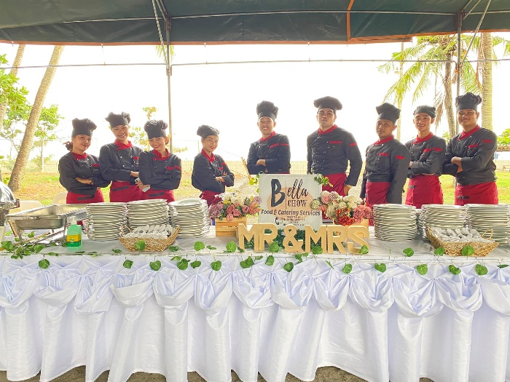

Miranda’s Foods and Catering

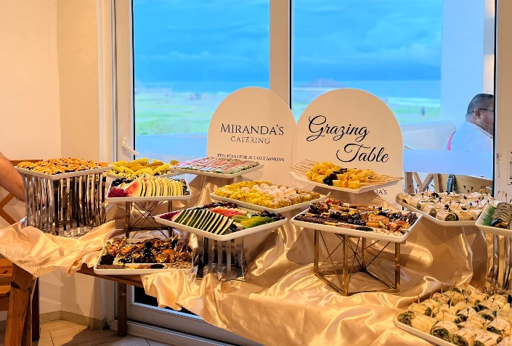

Viring's Heritage Cuisine Catering Services

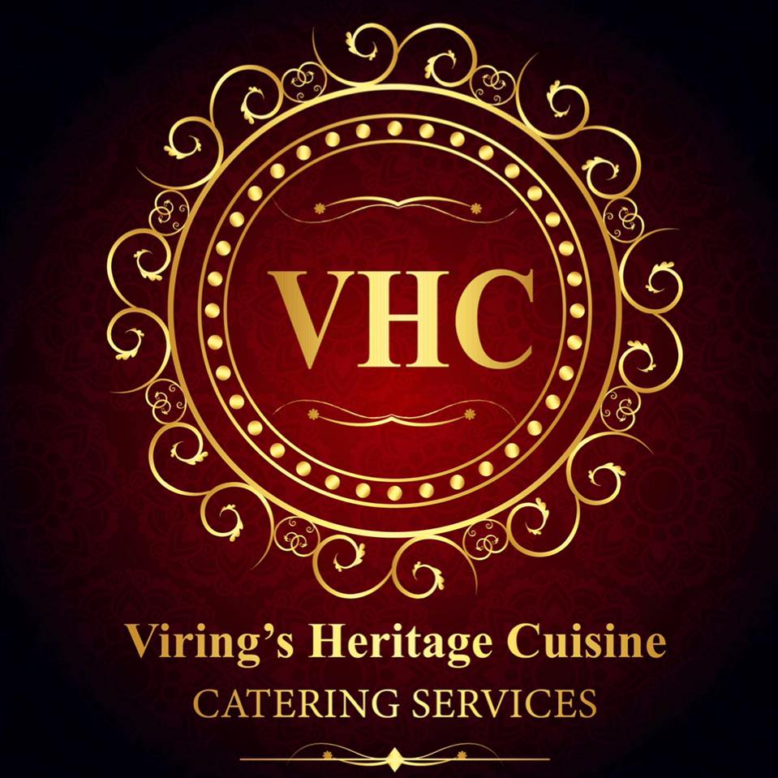

Cravings Catering Events Services

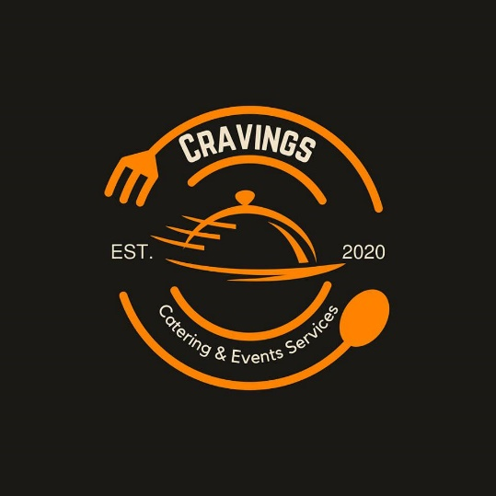

AJF Food garage catering services

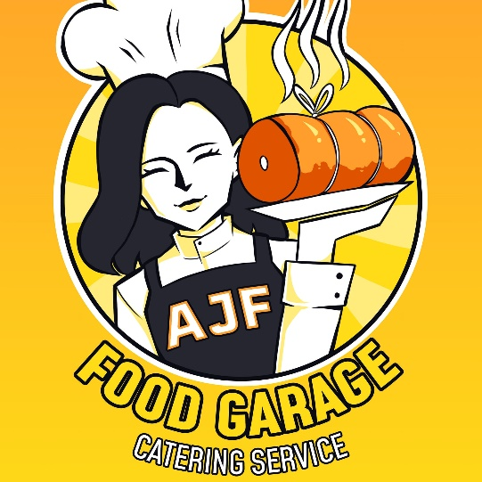

The Potluck Catering Services-

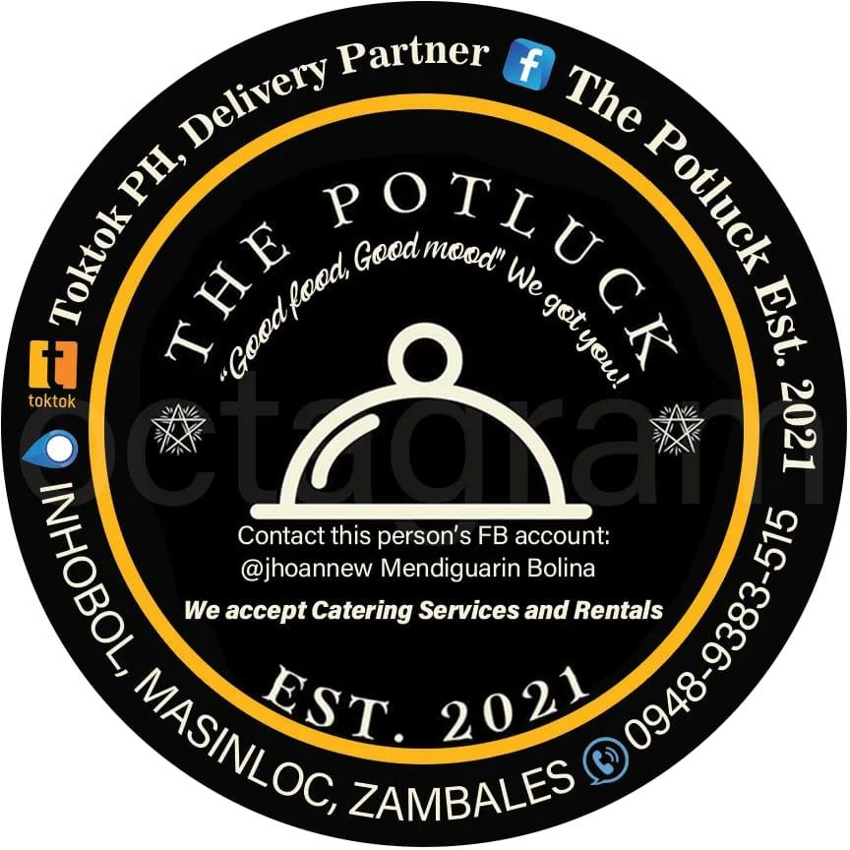

Kape Rustiko

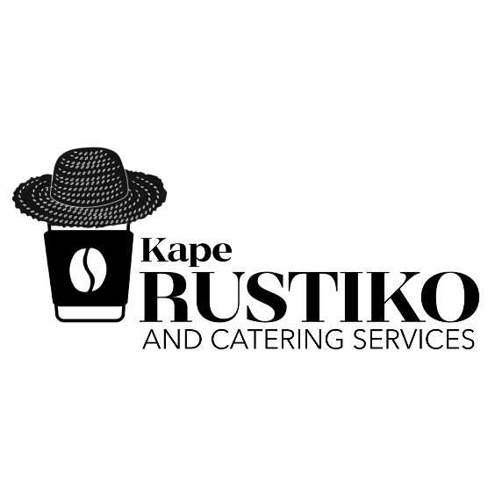

Jhayro's Catering and Food services

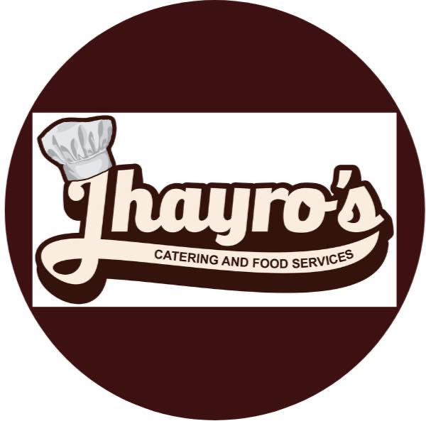

souvenir:

kapeng barako souvenirs

Shotglass

Clear Mugs

pot flower candle

Personalized Caricature Sintra board

photographer and videographer:

MoRii Films

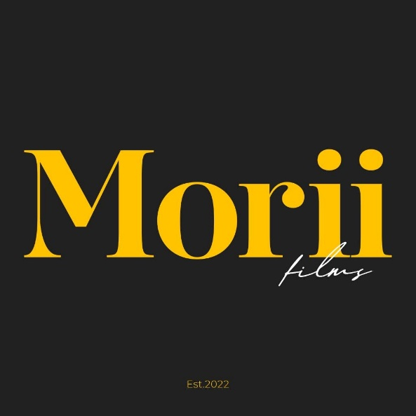

Ichthus Creatives

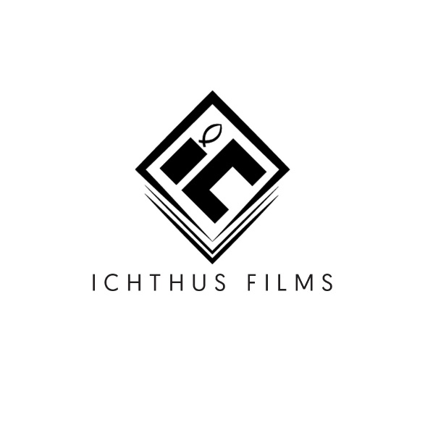

Miraya Studios

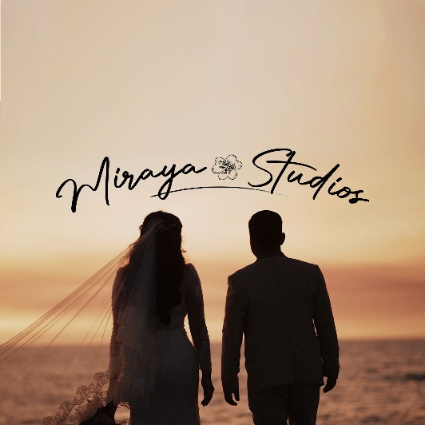

RAB Photo

Lathala and Chaptrs Studio

Jerome Foto and Films

Clicked by Nate and Neil Salvador

Chaptrs Studio



Glenn Isip Photography & Video Services

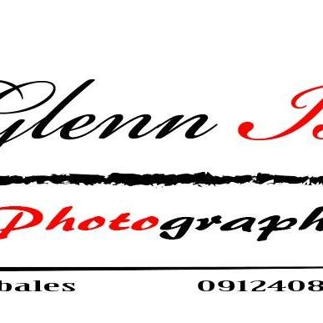

COLOVE STUDIOS